|  |
| --- |
| **it SUPPORT INSTRUCTION** |

**screen resolution FIX**

VERSION 1.0

INTRODUCTORY PROVISIONS

GOALS

This instruction defines the procedure for an employee to follow providing advice on fixing screen resolution parameters.

TASKS

The main objectives of the instruction are:

* description of the steps to take when PC has non correct screen resolution.

PERIOD OF VALIDITY AND PROCEDURE FOR MAKING CHANGES

Changes to the instruction are made when new settings appear in the SOFTWARE, as well as when information on current settings is updated.

**CHOOSINGG DISPLAY**

Before you get started, if you have external displays connected to your PC, choose the display you want to change.

1. Select **Start** > **Settings** > **System** > **Display**, and look at thesection that shows your displays.
2. Select the display you want to change. When that's done, follow the instructions below.  
   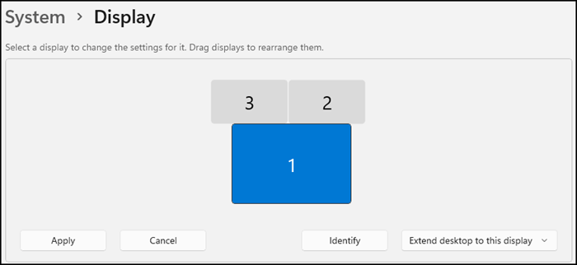

**Change the size of what's on the screen**

1. Stay in, or open, **Display**settings.  
   
2. Scroll to the **Scale & layout** section.
3. Select **Scale**, then select an option. Typically, it's best to choose the one that's marked (Recommended).

**Change the screen resolution**

1. Stay in, or open, **Display**settings.  
   
2. In the **Display resolution** row, select the list and choose an option. It's usually best to stick with the one that's marked (Recommended). Monitors can support resolutions that are lower than their native resolutions, but text won't look as sharp and the display might be small, centered on the screen, edged with black, or stretched.

**Note:**If you see unexpected changes in your screen resolution, your graphics driver might need to be updated. To see and install available updates, select **Start** > **Settings**> **Windows Update** > **Check for updates**.